Information on tourist spots around Ojiya
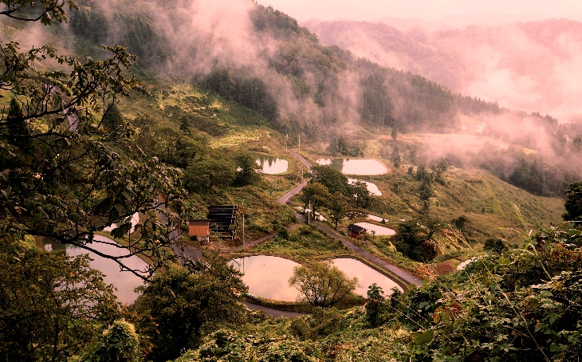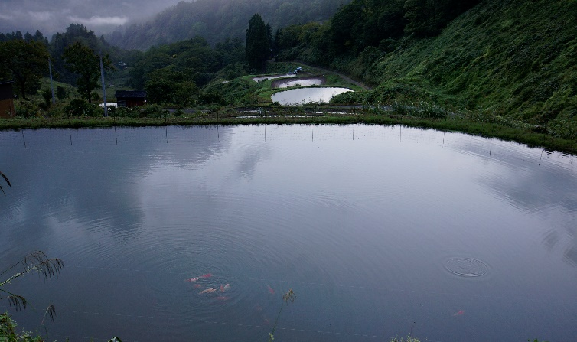
Tanaike (terraced ponds)/ Colored Carp Farming Pond

Ojiya is known for the birthplace of colored carp. It was born by mutation. When you go up Mt. kanagura located in Higashiyama district, there are colored carp farming ponds here and there making beautiful scenery like terraced rice fields. Water of carp farming ponds are all from rain water and snow water, and the system of using snow water for farming carps and making rice was designated as a national agricultural heritage. Terraced ponds and colored carp farming ponds look the most beautiful with sunrise and sunset.
Go see the breathtaking view!

*Do not get close to carp farming ponds. Please view from a distance.
Address: Oguriyama, Ojiya

